# A blue and red background Description automatically generatedautocompletes

Universal Search API

Autocompletes Release Document

# Introduction

* Autocompletes in search play a crucial role in enhancing user experience, improving search accuracy, and increasing efficiency.
* Purpose: To release autocomplete functionality for SE as part of initial rollout.
* New Features: Enhanced autocompletes which eases user efforts to find a company by name search.

# Version Information

* This is the initial version (1.0) of autocompletes as part of USP/V4 APIs
* Expected date of release: 28 March 2024

# Key Functionalities

* Better results first. The nearest best match to the user prefix is displayed in a sorted order.

Use case: A user wants to find a company name “AUT Consulting AB” by typing “aut” in the input text.

Here is V3 Autocompletes

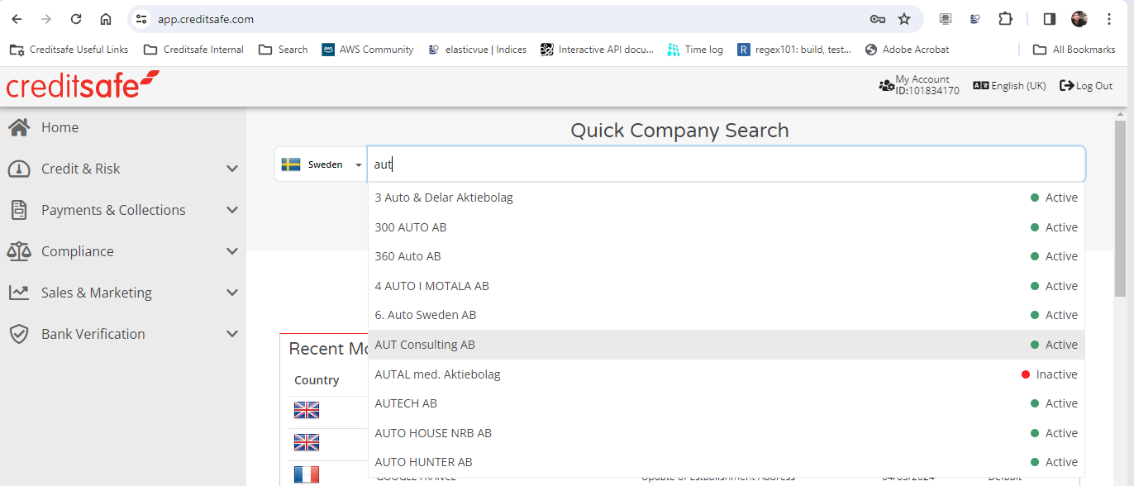

In USP/V4 Autocompletes

* Prioritizing the autocompletes results order.
  + Exact match
  + Case insensitive match
  + Alpha numeric
  + Special chars

V3 Autocompletes,

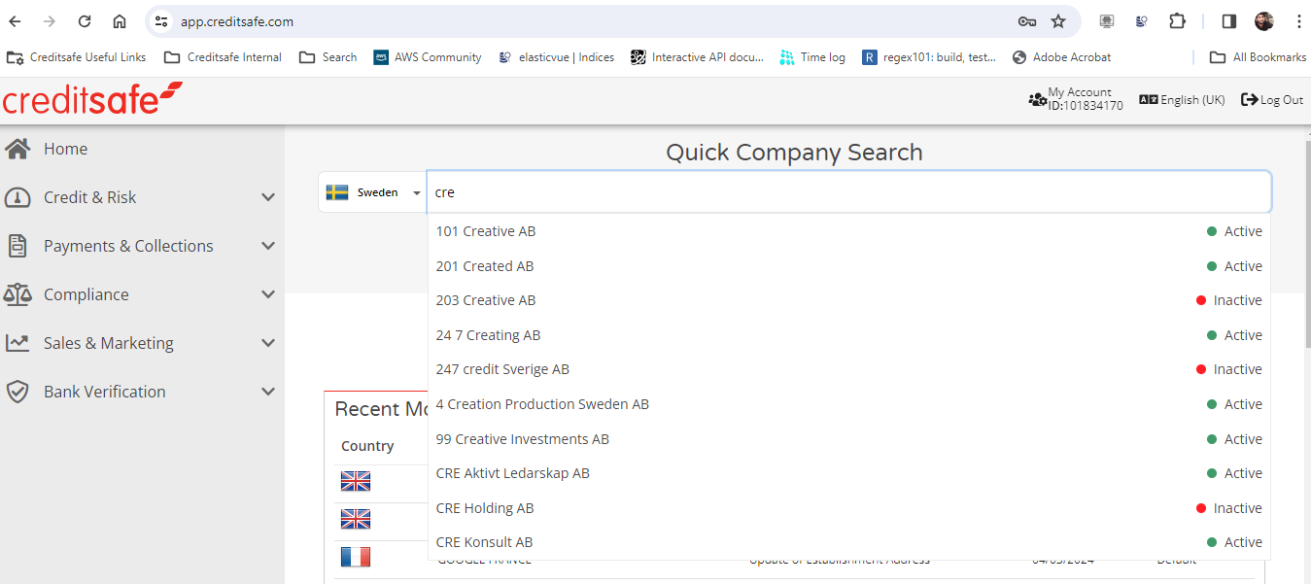

USP/V4 Autocompletes,

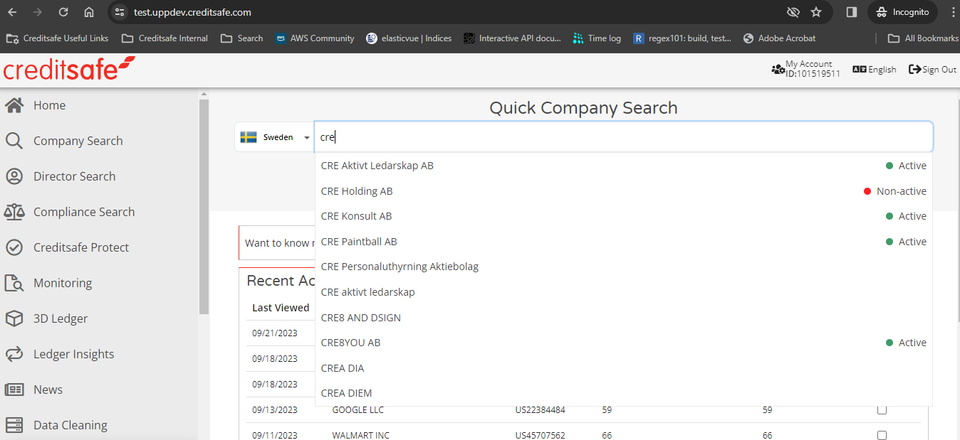

# Technical Changes

* A new autocomplete endpoint deployed with API gateway and domain mapped with Route53.
* API request changes:
  + The API route is changed from (V3)**/companies/{countryCode}/autocomplete** to (USP)**/companies/autocomplete**
  + API parameters changed from **CountryCodes** to **CountryCode** and **companyName** to **name**
* API response changes:
  + USP/V4 response object is same as V3.
  + The companies object is a list of companies with limited keys in USP/V4 compared to V3 to enhance the performance

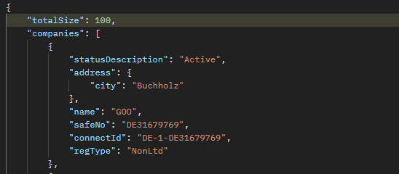

# Testing

* **Unit Testing**
  + To ensure the autocompletes work properly prior to any new changes - Unit test cases are integrated with deployment pipeline, and it is restricted to have all the unit test cases to pass before deploying any new changes.



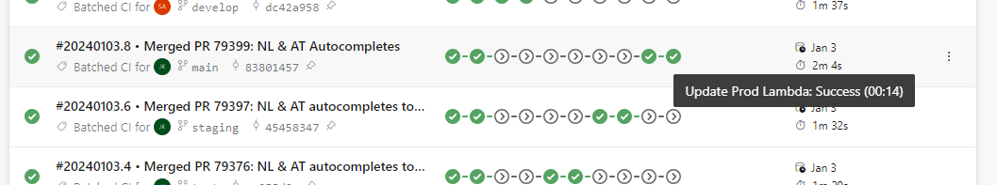

* **Regression Testing** 
  + A reference set run with 36K records iterating through each input character at random interval is used to test the autocompletes trying to simulate the real time usage.

* + The result of above run is positive with not much load on current infra/OpenSearch

* **Load Testing**
  + The current usage load of autocompletes for SE for a month and day metrics were captured from usage analytics.

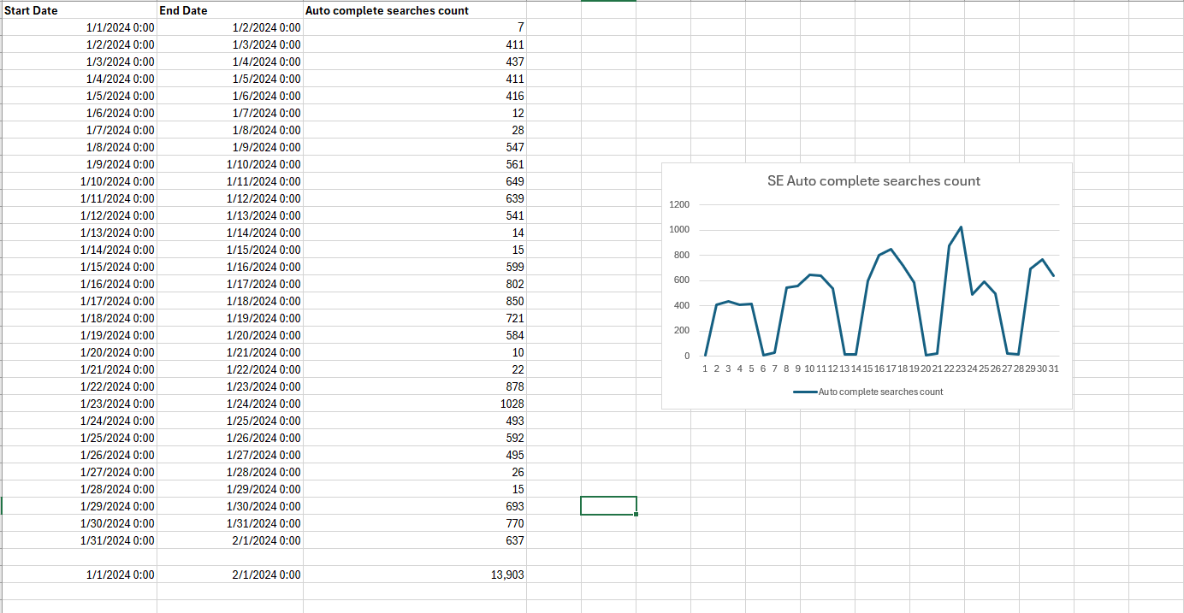

* + An API bulk trigger with a load of 1000 users are triggered to observe the performance which is way higher than the normal usage as per above statistics and all the requests are successful.

# Rollback strategy

* Connect to revert beta users to previous search version (V2) via a configuration change.
* Rollbacks can be done quickly (<30 mins)

# Risk/Impact Assessment

* Risk: Medium
  + Universal search is a new product and comes with inherent risk. Mitigating actions have been undertaken such as:
    - Regression testing
    - Benchmarking
    - UAT
    - Monitoring
    - Serverless architecture
  + Rollback is dependent on an external team (Connect)
* Impact: Low
  + SE users will be affected by this change.